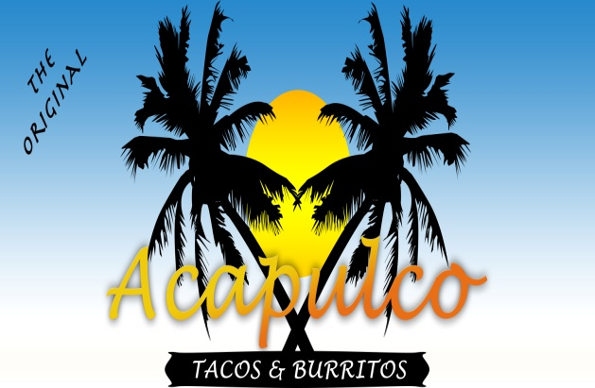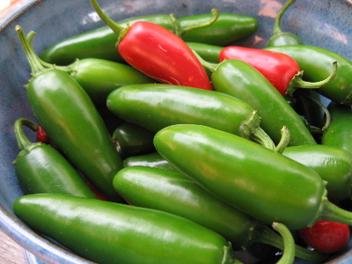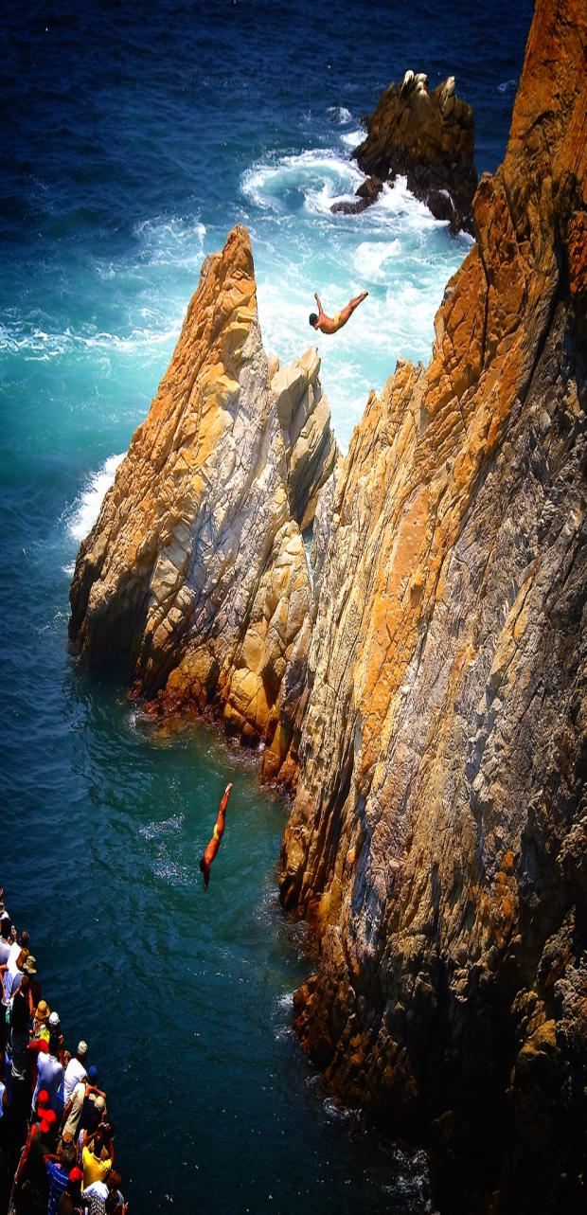

## A La Carte

Call Your Order

(505) 268-9865

Having an event, or a corporate meeting?

Call about Catering

840 San Mateo Blvd SE  
Albuquerque, NM 87108

Hours: Monday-Saturday

7:30am-7:30pm

Acapulco

Tacos & Burritos

Order Form

Qty. Menu Item Red/ Green

NAME:

***Taco*** - Shredded beef, lettuce, cheese and tomatoes **$1.85**

w/Beans - **$2.99**

***Enchilada*** - Tortilla, cheese and red chile **$1.75**

w/Beans- **$2.75**

***Tostada*** – Beans, meat, chile, cheese, lettuce and tomatoes - **$2.99**

***Tamale*** *-* $**1.85**

***Beans & Cheese*** *(side) -* **$2.20**

***Rice & Cheese*** *(side) -* **$2.20**

***Chile Relleno*** - **$2.99**

w/Beans - **$3.50**

***Chile con Carne*** - Cheese, tortilla and your choice of red or green chile **$5.55**

***Acapulco Salad*** *-* **$3.60**

***Guacamole Salad*** **- $4.99**

***Nachos*** - Chips, cheese and jalapenos $**3.50**

**Cheese Quesadilla** - Tortilla and cheese **$2.99**

### Combos / Plates

All combos come with a salad, one flour tortilla, and a side of rice and beans.

### Regular

### Burritos

1. ***-Red Regular***– Savory meat simmered in red chile with beans and cheese - **$4.60**
2. ***Green Regular***– Savory meat simmered in green chile with beans and cheese - **$4.60**
3. ***Red All Meat***– Meat simmered in red chile with cheese - **$4.90**
4. ***Green All Meat***– Meat simmered in green chile with cheese - **$4.90**
5. ***Machaca***– Shredded beef, slow cooked in spices with beans, onion sauce, cheese and your choice of chile - **$4.90**
6. ***Chorizo***– Mexican sausage cooked in eggs with onions, beans and cheese - **$4.60**
7. ***Chile Relleno***– Green chile stuffed with cheese with onion sauce and beans wrapped in a flour tortilla - **$4.60**
8. ***Beans, Cheese & Rice*** - **$3.75**
9. ***Beans & Cheese*** - **$3.75**
10. ***Picado***– Diced pork meat, onion sauce, cheese and your choice of chile - **$4.90**
11. ***El Burrote***– (Biggest Burrito) Simmered meat (your choice of red or green chile) beans, rice, lettuce, tomato and cheese - **$6.95**
12. ***Carne Adovada***–Meat cooked in red chile with cheese - **$4.90**
13. ***Chicharron***– Chicharrones, beans, cheese and your choice of chile - **$4.60**
14. ***Carne Asada***– Diced beef, beans, cheese and your choice of chile - **$4.90**

* ***Puerto Vallarta*** – Taco, enchilada, meat and bean burrito - **$7.99**
* ***Acapulco*** – Chile relleno, enchilada and red carne adovada – **$7.50**
* ***Ranchero*** – Carne adovada, onion sauce and an enchilada - **$6.50**
* ***Taco/Enchilada*** – 1 taco & 1 enchilada or 2 tacos; or 2 enchiladas - **$6.25**
* ***Burrito Special*** – Meat burrito smothered in red or green chile w/cheese (no extra tortilla) - **$6.25**
* ***Tamale Special*** – Two tamales smothered with red chile, and a side of carne adovada **$6.25**

Coke, Diet Coke, Sprite,

Dr. Pepper, Lemonade, Fruit Punch,

and Ice Tea

***Medium*** **- $1.40**

***Large*- $1.85**

***Coffee* - $1.00 / *Orange Juice* – $1.50**



***Coffee*** (12 oz) - $1.00

***Orange Juice*** (10 oz) - $1.50

Breakfast Served Until 11:00 am

*Now Serving Coffee and Orange Juice!*

1B***. Burrito –*** Potato, beans, eggs, chile, andcheese - **$4.60**

2B***. Chorizo Burrito*** – Mexican sausage cooked in eggs, with beans, onionsand cheese - **$4.60**

3B***. Meat Burrito –*** Meat, potato, eggs, beans, chile and cheese **$4.65**

4B***. Huevos Rancheros*** – Two eggs over a corn tortilla served w/hash browns, beans, chile, cheese and a flour tortilla **$6.30**

5B***. Bacon Burrito***– Bacon, potato, beans, eggs, chile and cheese **$4.65**

### Drinks



# Breakfast